Microprocessor and Computer Architecture
UE24CS251B
4th Semester, Academic Year 2025-26
Date:
Name: Harshit Chandak | SRN:  PES2UG24CS185 | Section  C

LAB #____3_______ Program Number: ____1___
Title of the Program
Write an ALP to perform Addition for of two numbers of sizes 64 bit and 128 bit and save the result in register (reuse the register to store the result)
Hint:
R3 R2 R1 R0
+ R5 R4

- Typed ARM Assembly Code
- Three Output Screen Shots (one for each case )
( Screenshot including Register Window,Output Window and Code Window)

MOV R0,#0xAA
MOV R1,#0xBB
MOV R2,#0xCC
MOV R3,#0xDD

ADDS R3,R0,R2
ADC R4,R1,R3

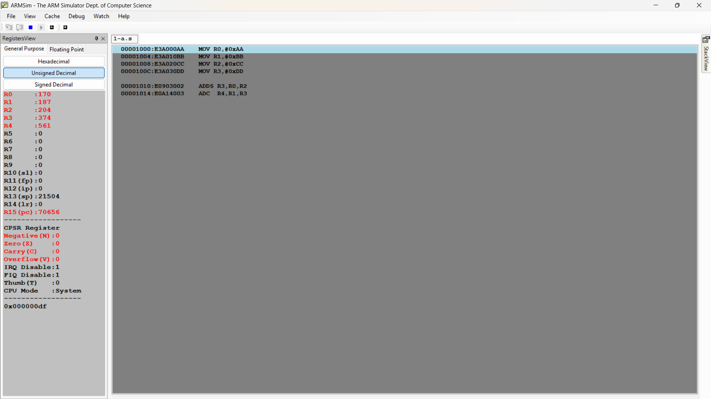

MOV R0,#0xAA
MOV R1,#0xBB
MOV R2,#0xCC
MOV R3,#0xDD
MOV R4,#0xEE
MOV R5,#0xFF
MOV R6,#0x11
MOV R7,#0x22

ADDS R8,R0,R4
ADC R9,R1,R5
ADC R10,R2,R6
ADC R11,R3,R7

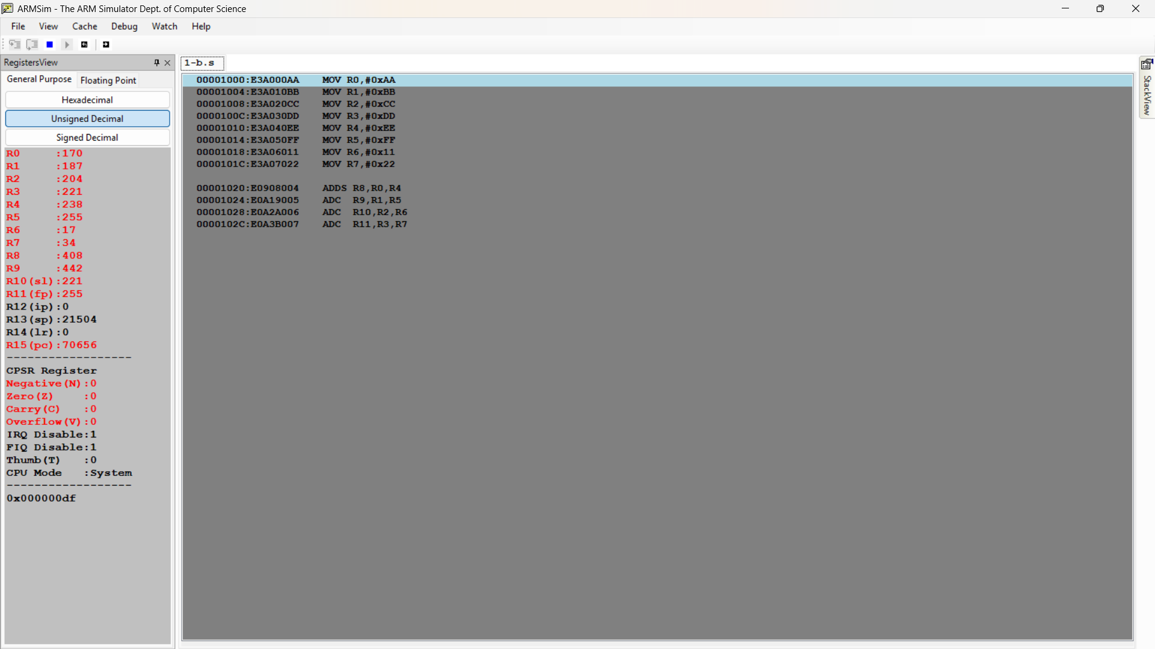
Microprocessor and Computer Architecture
UE24CS251B
4th Semester, Academic Year 2025-26
Date:
Name: Harshit Chandak | SRN:PES2UG24CS185 | Section

LAB #____3_______ Program Number: ____2___
Title of the Program
Write a program to find the factorial of a given number.

(One Screenshot including Register Window,Output Window and Code Window,Memory Window)
MOV R0,#1
MOV R1,#5

FACT:
MUL R0,R1,R0
SUB R1,R1,#1
CMP R1,#1

BNE FACT

SWI 0x11

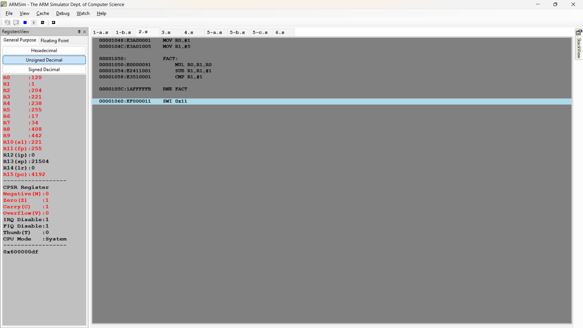

Microprocessor and Computer Architecture
UE24CS251B
4th Semester, Academic Year 2025-26
Date:
Name: Harshit Chandak | SRN:  PES2UG24CS185 | Section  C

LAB #____3_______ Program Number: ____3___
Title of the Program
Write an ALP to find the number of zeroes, positive and negative numbers in a given array

- ARM Assembly Code
- Output Screen Shots
(One Screenshot including Register Window,Memory Window and Code Window)
.DATA
A: .WORD 1,0,-1,2,-3,4,-5,0,0,7

.TEXT

LDR R0,=A

MOV R2,#0
MOV R3,#0
MOV R4,#0
MOV R5,#0

LOOP:
LDR R1,[R0]
CMP R1,#0
BEQ ZERO
BGT POS
BLT NEG

ZERO:
ADD R3,R3,#1
B NEXT
POS:
ADD R4,R4,#1
B NEXT
NEG:
ADD R5,R5,#1
B NEXT

NEXT:
ADD R0,R0,#4
ADD R2,R2,#1
CMP R2,#10
BNE LOOP

SWI 0x11

.END

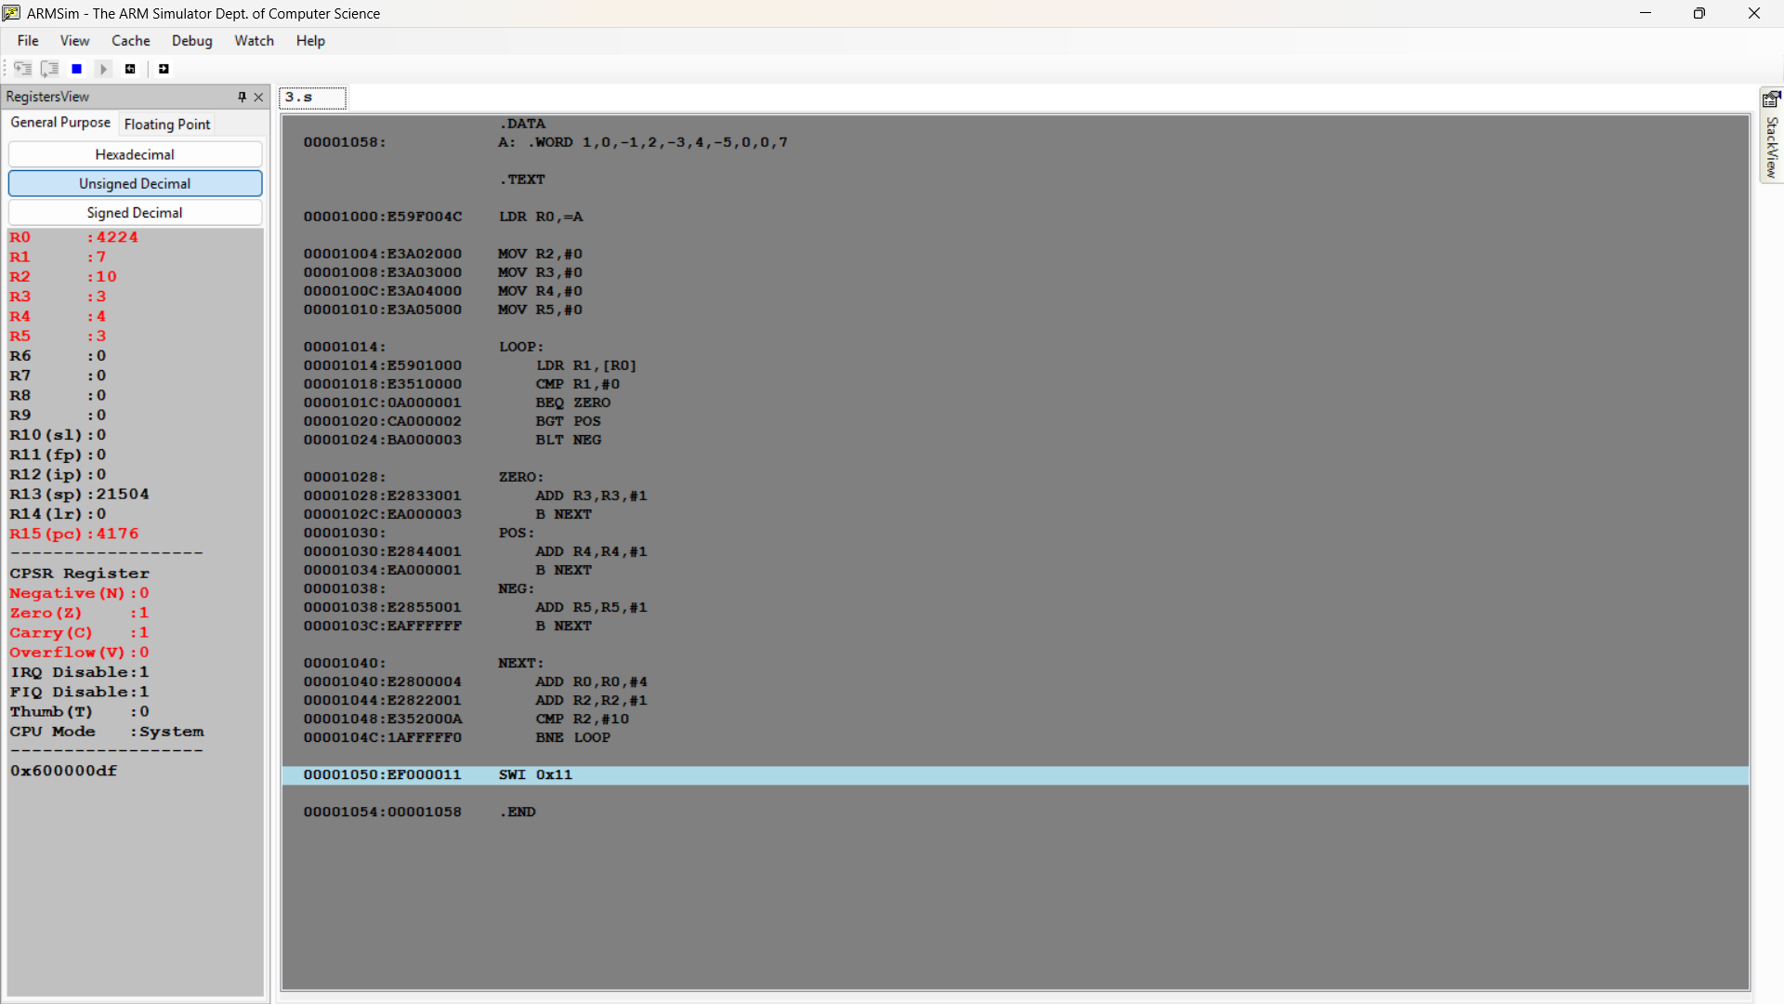

Microprocessor and Computer Architecture
UE22CS251B
4th Semester, Academic Year 2023-24
Date:
Name: Harshit Chandak | SRN:  PES2UG24CS185 | Section  C

LAB #____3_______ Program Number: ____4___
Title of the Program
Write a program to perform 3X3 matrix addition.
- ARM Assembly Code
- Output Screen Shots
(One Screenshot including Register Window,Memory Window and Code Window)

.DATA
A: .WORD 1,2,3,4,5,6,7,8,9
B: .WORD 1,2,3,4,5,6,7,8,9
C: .WORD 0,0,0,0,0,0,0,0,0

.TEXT

LDR R0,=A
LDR R1,=B
LDR R2,=C

MOV R5,#0

LOOP:
LDR R3,[R0]
LDR R4,[R1]
ADD R4,R3,R4
STR R4,[R2]

ADD R0,R0,#4
ADD R1,R1,#4
ADD R2,R2,#4

ADD R5,R5,#1
CMP R5,#9

BNE LOOP

SWI 0x11

.END

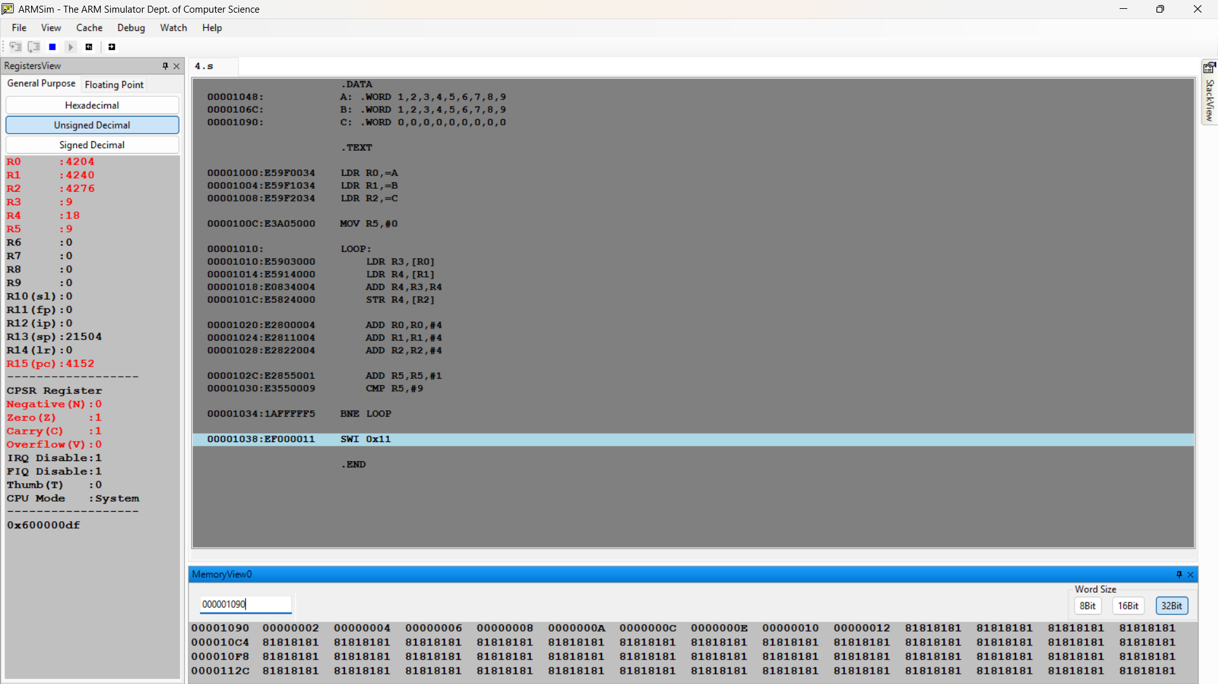

Microprocessor and Computer Architecture
UE22CS251B
4th Semester, Academic Year 2023-24
Date:
Name: Harshit Chandak | SRN:  PES2UG24CS185 | Section  C

LAB #____3_______ Assignment Question 1
Title of the Program
- Write a program in ARM7TDMI-ISA to find the sum of N data items at alternate [ odd or even positions] locations in the memory. Store the result in the memory location.
- Use Pre-indexing addressing mode
- Use post-indexing addressing mode
- Use Auto-indexing addressing mode

- ARM Assembly Code
- Output Screen Shots
(One Screenshot for each case including Register Window,Memory Window and Code Window)
.DATA
A: .WORD 10,1,2,3,4,5,6,7,8,9

.TEXT

MOV R0,#0
MOV R2,#0

LDR R1,=A
LDR R3,[R1]
ADD R2,R2,R3

ALT:
LDR R4,[R1,#8]
ADD R1,R1,#8
ADD R2,R2,R4
ADD R0,R0,#1
CMP R0,#4
BNE ALT

.END
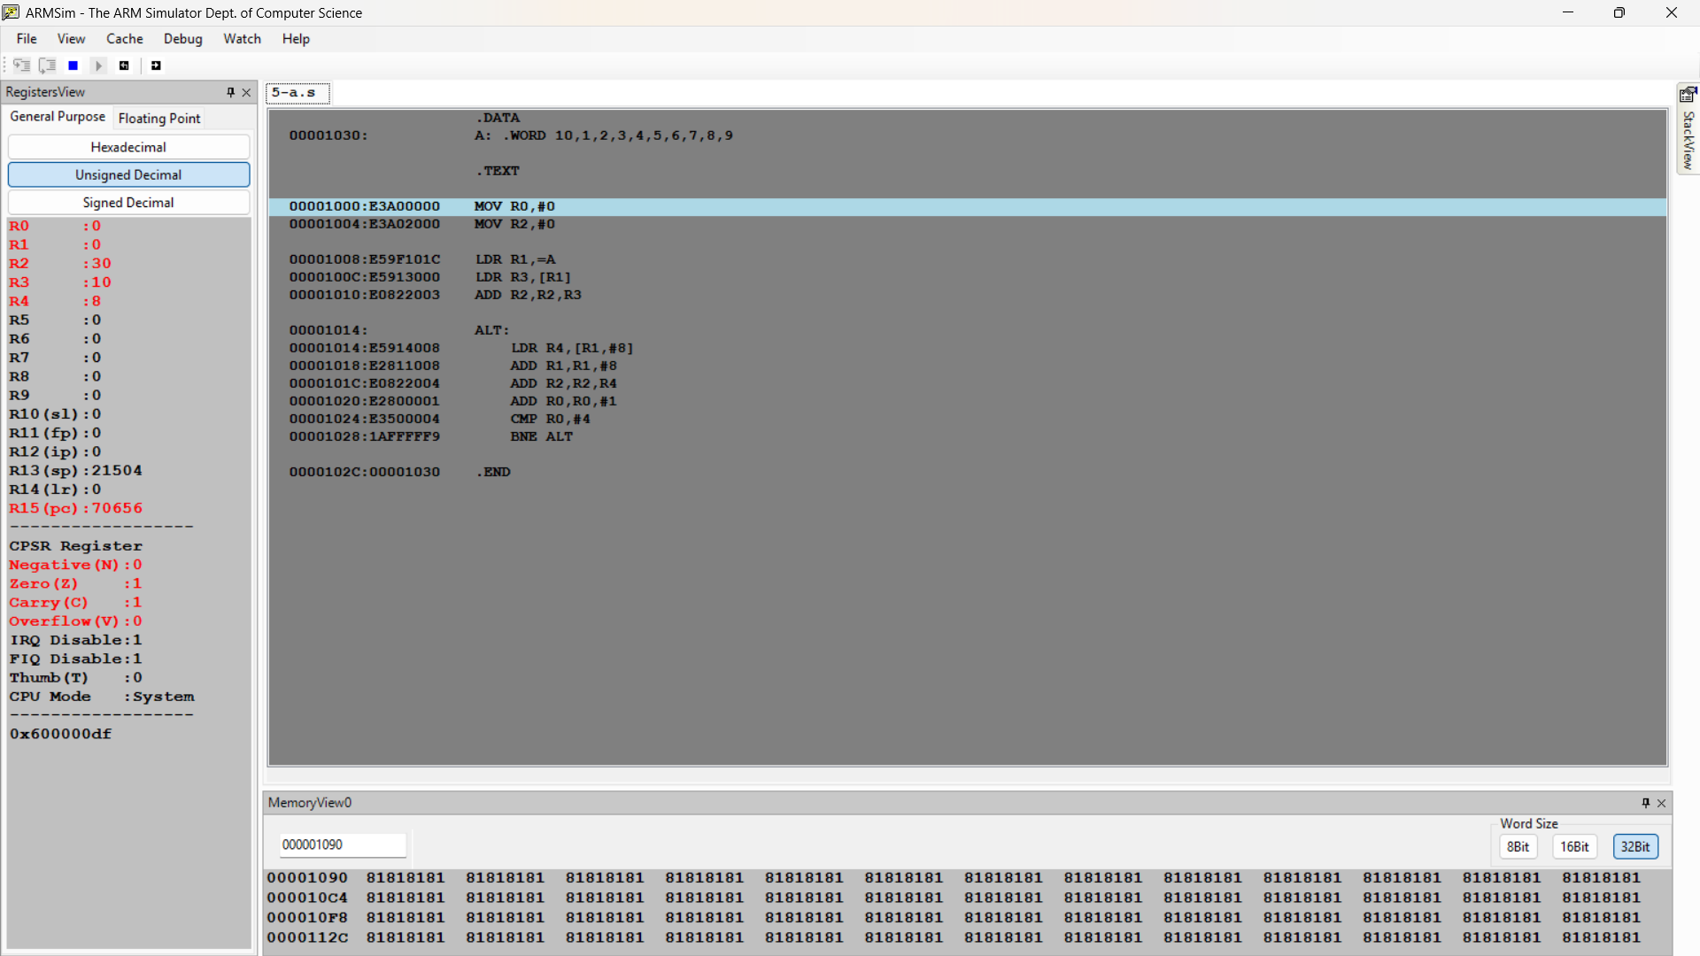
.DATA
A: .WORD 10,1,2,3,4,5,6,7,8,9

.TEXT

MOV R0,#0
MOV R2,#0

LDR R1,=A
LDR R3,[R1]
ADD R2,R2,R3

ALT:
LDR R4,[R1,#8]!
ADD R2,R2,R4
ADD R0,R0,#1
CMP R0,#4
BNE ALT

.END
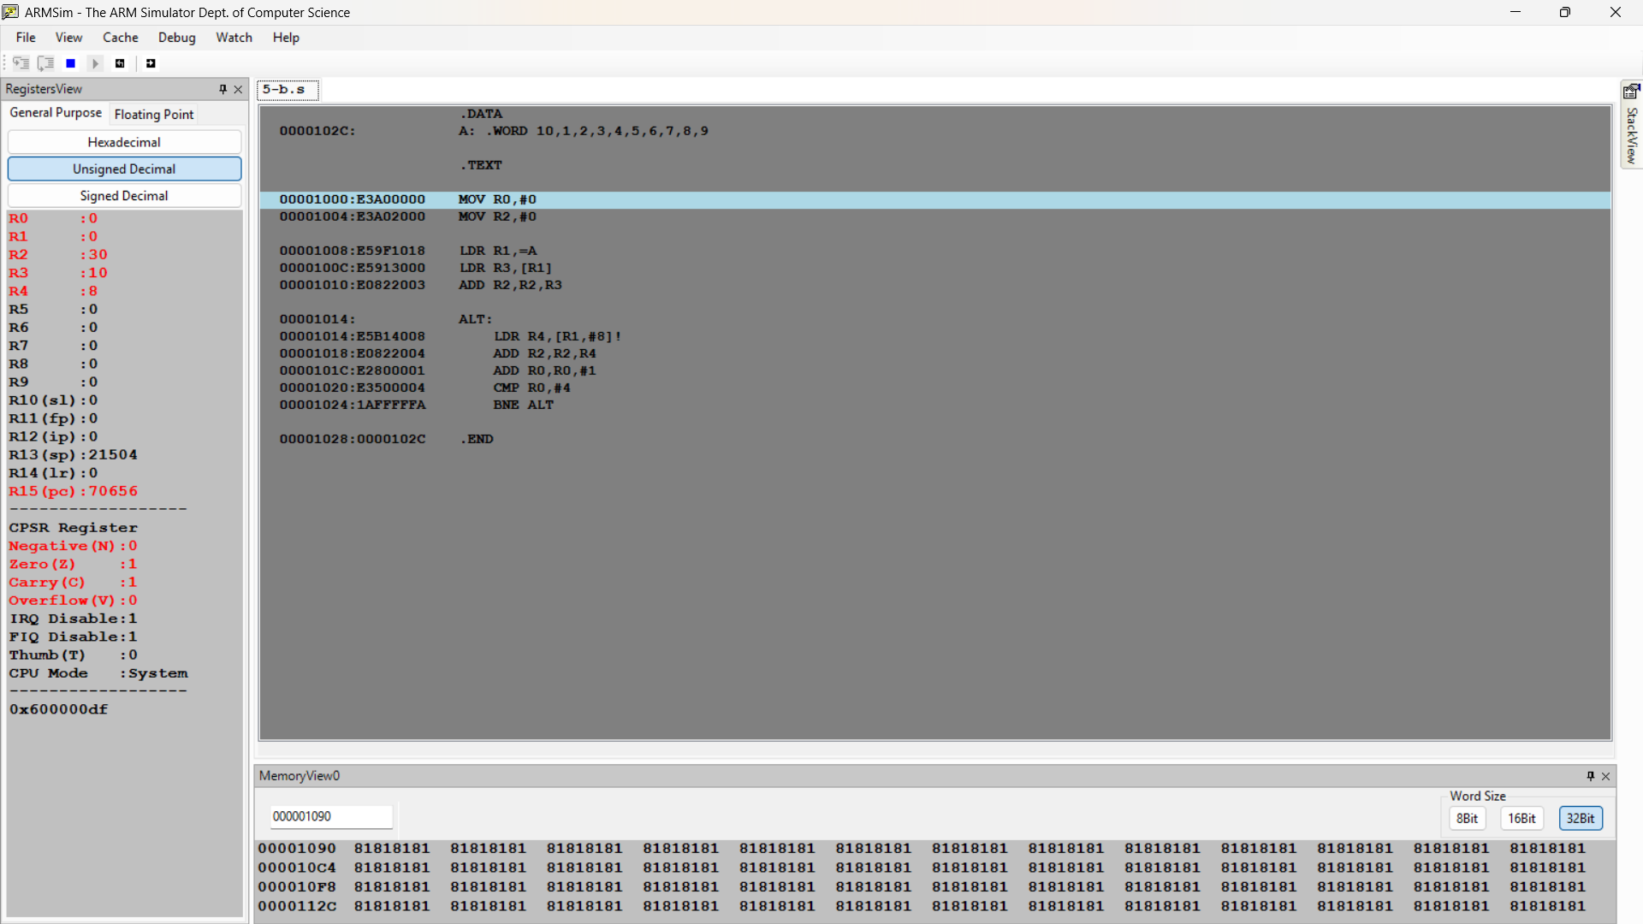

.DATA
A: .WORD 10,1,2,3,4,5,6,7,8,9

.TEXT

MOV R0,#0
MOV R2,#0

LDR R1,=A

ALT:
LDR R4,[R1],#8
ADD R2,R2,R4
ADD R0,R0,#1
CMP R0,#5
BNE ALT

.END

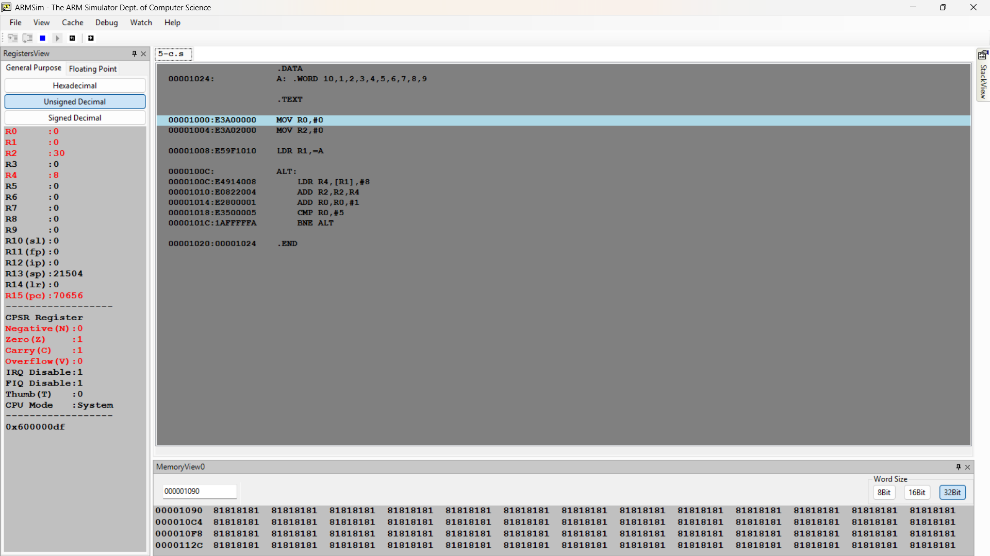

Microprocessor and Computer Architecture
UE22CS251B
4th Semester, Academic Year 2023-24
Date:
Name: Harshit Chandak | SRN:  PES2UG24CS185 | Section  C

LAB #____3_______
Assignment Question 2
Title of the Program
- Write an ALP to perform 2’s complement, Only using MOV and RSB instruction.
- ARM Assembly Code
- Output Screen Shots
(One Screenshot including Register Window,Memory Window and Code Window)

MOV R0,#5
MOV R2,#1
RSB R1,R0,R2,LSL #4

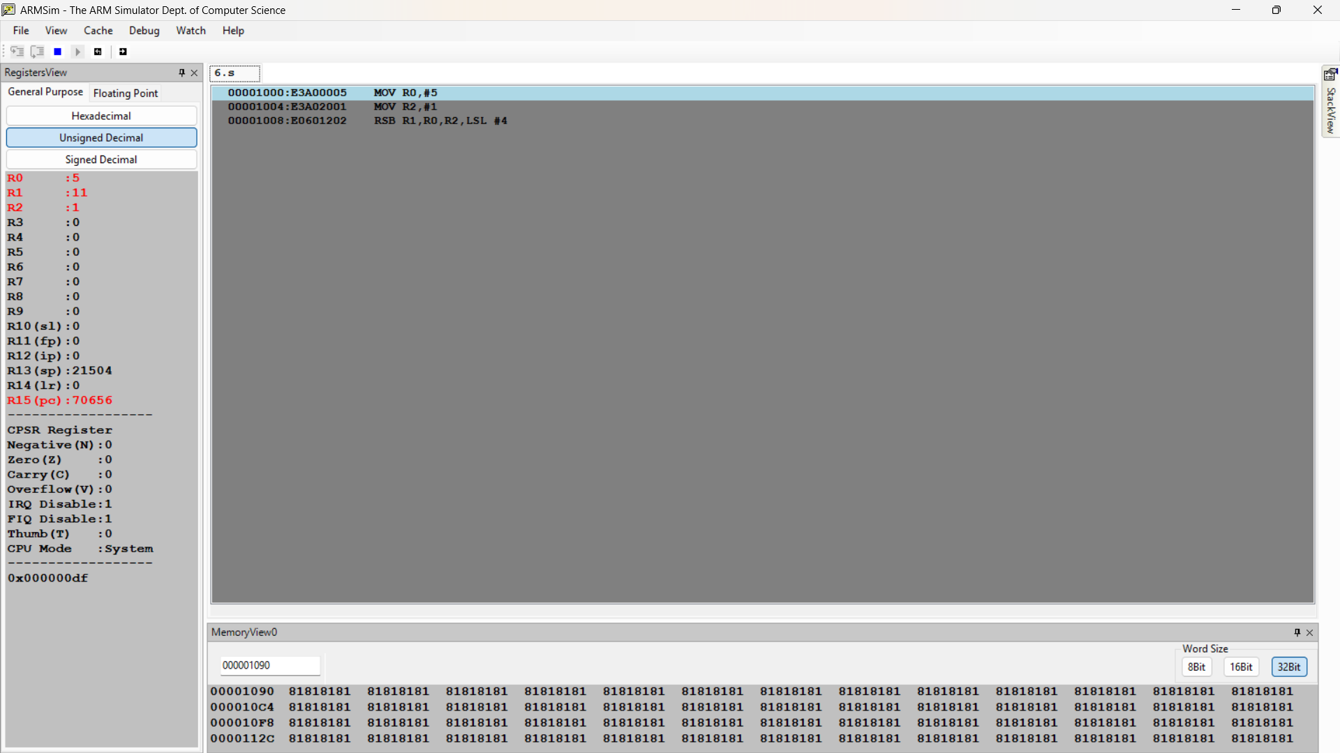

Disclaimer:
- The programs and output submitted is duly written, verified and executed by me.
- I have not copied from any of my peers nor from the external resource such as internet.
- If found plagiarized, I will abide with the disciplinary action of the University.

Signature:
Name:
SRN:
Section:
Date:

